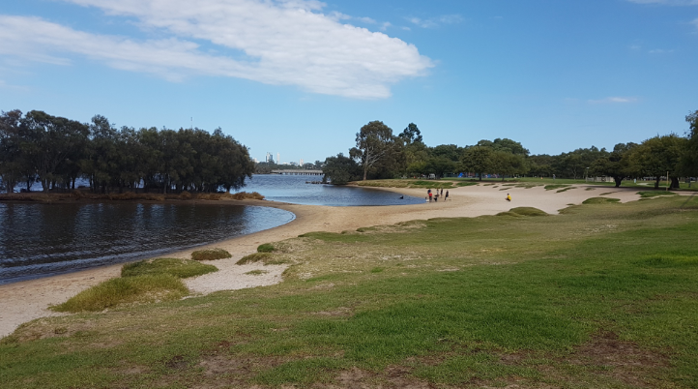

Swan Canning River Field Report

-Bayswater Riverside Gardens

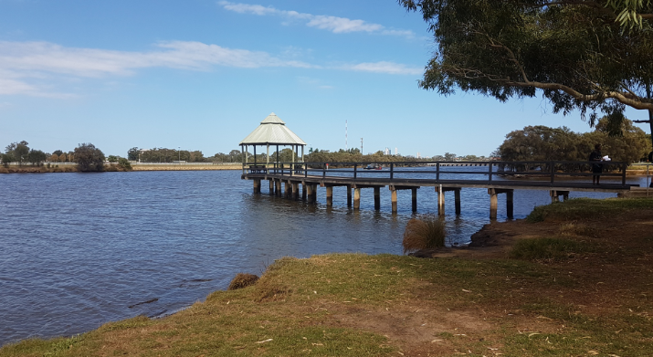

|  |  |
| --- | --- |
| **Table of Contents/List of Figures** | |
| Field Trip Summary | Page 3 |
| Site Location | Page 3 |
| Site Survey | Page 4 |
| Water Quality Testing | Page 5 |
| Macroinvertebrate Sampling | Page 6 |
| Birds of the Wetland | Page 7 |
| Evaluation | Page 8 |
| Conclusion | Page 8 |
| References | Page 9 |

**Field Trip Summary**

We are conducting an excursion to the Swan River System at Riverside Gardens in Bayswater. We are going to explore the water quality, land cover, biodiversity loss and sustainability of this wetland. We will conduct these tests by undergoing a Site Survey, Water Quality Sampling, Macroinvertebrate sampling and identifying bird species in the wetland.

**Site Location**

The Location of the site is 123 Milne Street in Bayswater, 6031. The coordinates of the site are 31.9273° S, 115.9230° E

**Site Survey:**

Summary of Site:

|  |  |  |
| --- | --- | --- |
| **Table 1:** | | |
| **Category** | **Observations** | **Score** |
| Vegetation | -Lots of reeds along edges on river.  -Large areas of cleared land with grass.  -Newly planted trees.  -Dead trees in the water and near edge of river. | 2- Some native plants and many introduced plants. |
| Water | -Murky, brown. | 2- |
| Smell | -Smelt like water and dog poo.  -Natural smelling, no chemicals. | 3- |
| Banks | -Erosion at edge of the river due to water action from boats. | 2- |
| Animal Life | -Not many water birds-we saw 2 ducks and a pelican.  -Many dogs and humans around.  -Bird sanctuary near by to filter out phosphates and nitrates. | 2- |
| Litter | -Not much rubbish around, however some dog poo and concrete/bricks near waters edge. | 3- |
| Pipes and drains | -Main storm water drain for Bayswater | 3- |
| Land Use |  | 2- |
| Human Use |  | 2- |
| How do you feel? |  | 3- |
| **Overall Score** |  | **24-Medium** |

Score of 24 was in the medium rating range. Further investigation of this area is required and may include a water monitoring program over a longer period.

**Water Quality Testing:**

Summary of Water Quality:

|  |  |  |
| --- | --- | --- |
| **Table 2:** Comparison between ANZECC trigger values and actual measurements taken from a water sample collected at the Riverside Gardens Swan River System. | | |
| **Water Measurement** | **ANZECC trigger value for this site** | **How our result compares?** |
| **Temperature** |  | 27.5 |
| **pH** | 7.5-8.5 | 7.82-normal |
| **Salt-mS/cm** | Not applicable | 45.3-Saline |
| **Turbidity-NTU’s** | 1-2 | <40-very high turbidity, light penetration into water column was extremely affected due to the sand and particles suspended. |
| **Dissolved Oxygen-% saturation** | 90-110% | 101.7%-slightly more oxygen entering than leaving the water. |
| **Phosphates-ppm mg/L** | 0.005 | 0.614-massively high-can greatly impact ecosystem. |
| **Nitrates-ppm mg/L** | 0.045 | 3.544-massively high-can greatly impact ecosystem. |

The pH and dissolved oxygen at this site are within the ANZECC trigger values, thus normal. However, the salinity, turbidity, and phosphate and nitrate concentrations were extremely high. Further investigation is required at this site and management is required to avoid a future problem.

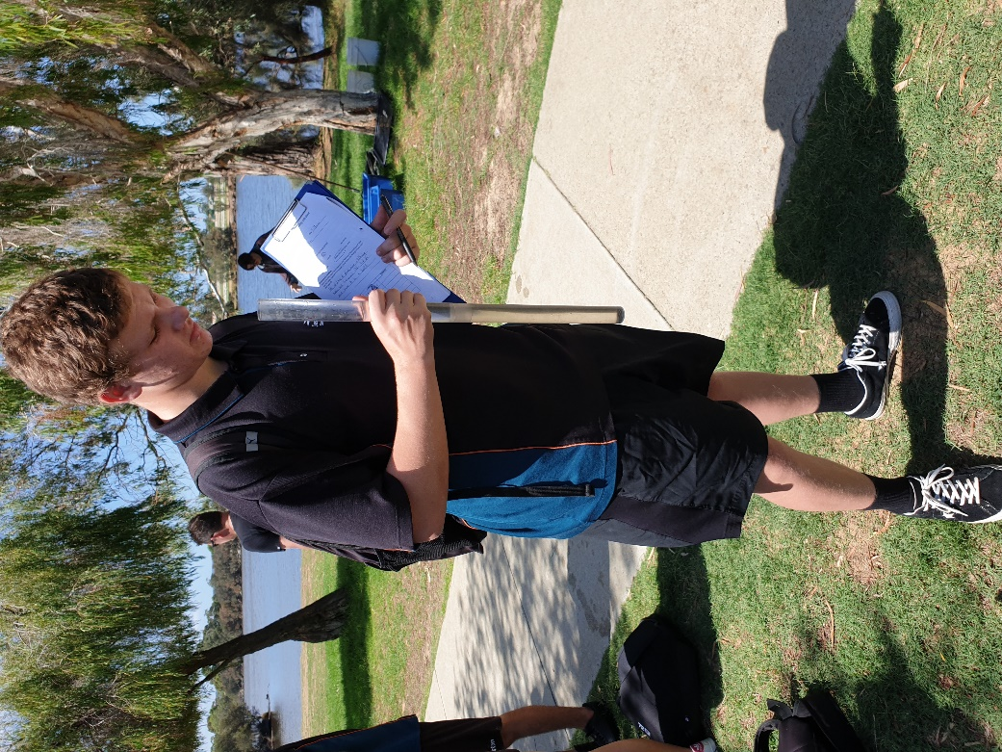

**Macroinvertebrate Sampling:**

Summary of Macroinvertebrates:

|  |  |  |  |
| --- | --- | --- | --- |
| **Table 3:** Observed Macroinvertebrates in a sample of water collected at the Riverside Gardens River System. | | | |
| **Name** | **Classification** | **Number Present** | **Abundance Rating** |
| Tiny Shrimp | Crustacean | 9 | common |
| Worm | Annelida | 1 | uncommon |
| Freshwater Snail | Mollusca | 5 | common |
| Dragonfly Nymph | Insectia | 1 | uncommon |
| Water Scorpion | Arachnida | 1 | uncommon |

Only 5-6 different macroinvertebrate species were found in our water sample which means this site only provides an environment with a few macroinvertebrates and low biodiversity.

We visited the site in summer which indicates the following:

* Some insect species are in adult form rather than aquatic larva form.
* Summer is hotter which means water temperature is higher which affects the numbers of organisms.
* The water flows quite constantly due to boat movement and massive storm rains from a week ago would have washed many away.
* We collected our sample from the sand rather than near reeds which would have greater biodiversity.
* Water quality is low due to high phosphate and nitrate samples.
* Large storm water drain that empties into this part of the river which would pollute the area with fertiliser runoff and fuels/oils from cars.

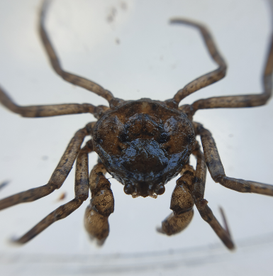 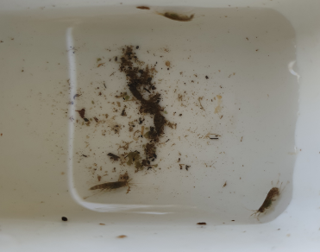

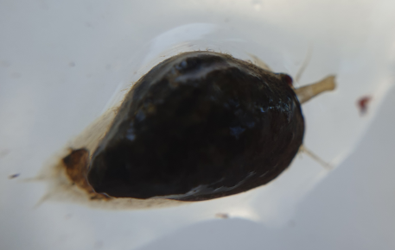

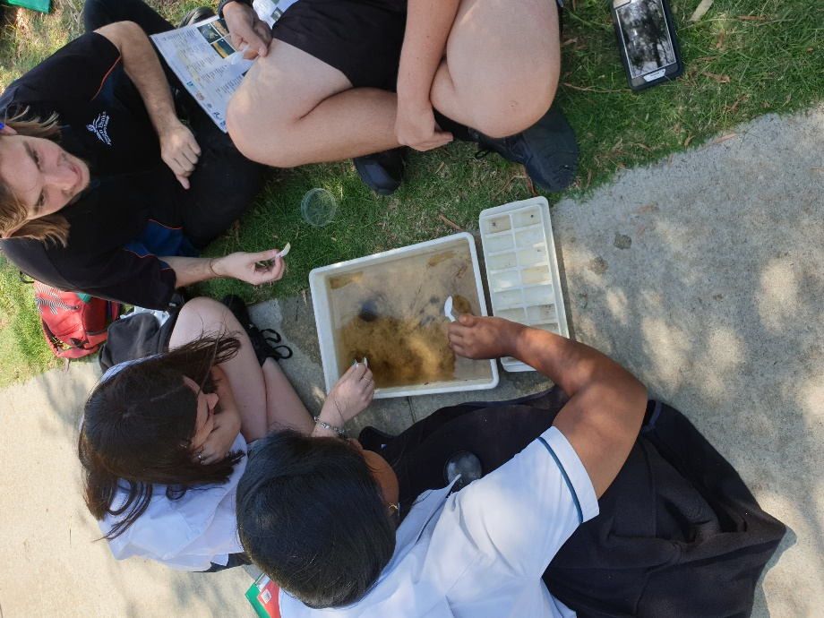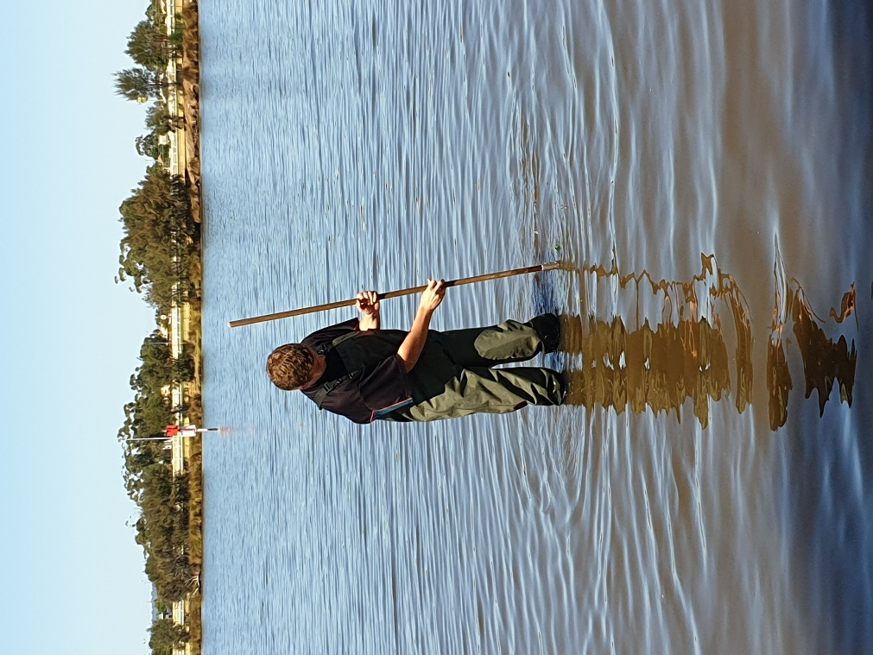

**Birds of the Wetland:**

Summary of Bird species:

|  |  |  |
| --- | --- | --- |
| **Table 4:** Species and Numbers of Birds Identified at the Riverside Garden River System. | | |
| **Type of Bird** | **Species Identified** | **Number of Organisms** |
| Large water birds | Black swans | 0 |
| Large wading birds | Pelicans | 1 |
| Ducks and grebes | Wood duck  Pacific black duck | 2 |
| Water hens | none | 0 |
| Cormorants and darters | none | 0 |
| Small wading birds | none | 0 |
| Gulls/terns | none | 0 |
| Birds of prey | none | 0 |
| Bush birds | Singing honey eater  Magpie Lark (Mudlark)  Red wattle bird  Willy wag tail  Swallow  Kookaburra | 7 |

A few bush birds were seen but minimal water birds, this would be due to the high predominance of dogs and humans in the area. There was also minimal trees and bushes due to large clearings of land with grass.

Artificial hollows for birds and more trees can be added to help increase biodiversity.

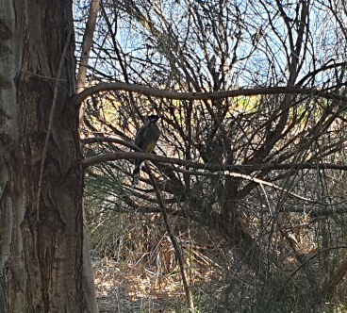

**Evaluation:**

**Conclusion:**

**References:**